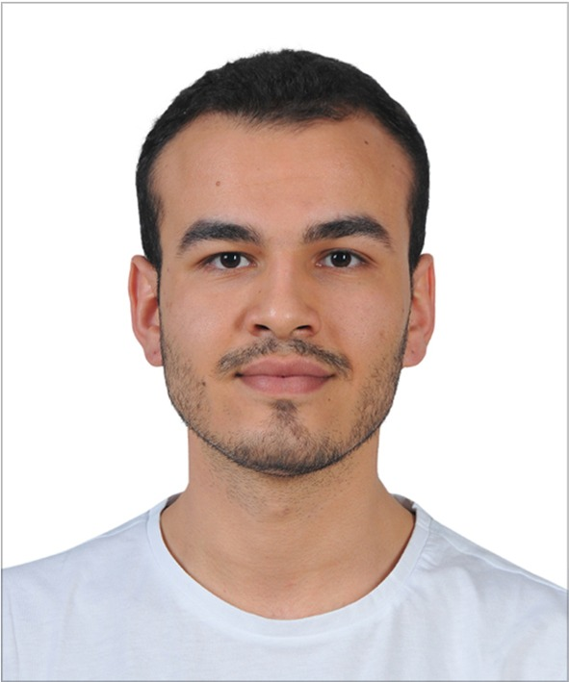

**Emre Deniz ŞENEL**

Undergraduate Senior Student of Electrical and Electronics Engineering of Middle East Technical University

Location: Ankara / Turkey

Telephone: +90 539 587 02 18

Email: emre.senel@metu.edu.tr

Professional profile

Summarise your career from both an academic and workplace standpoint being sure to include your highest academic achievements, along with types of organisations you have worked for and commercial work you have been involved in. Also add any notable research and publications.

Career Summary

**June 2019 – July 2019 ASELSAN Electronics Inc., Ankara**

**Student Intern**

*Outline*

As a summer intern, my goal was to observe defence industry and experience practical implementations of my theoretical background.

*Key responsibilities*

* Designed interfaces using MATLAB and GUIDE software.
* Analysed intrinsic and extrinsic parameters of cameras.
* Implemented a simulation software of aircraft located camera
* Debugged C++ code which implements car tracking.
* Analysed different feature detection and feature extraction algorithms.
* Tested runtimes of different matching algorithms.

**July 2018 – September 2018 TOYOTA Motor Manufacturing Turkey, Sakarya**

**Student Intern**

*Outline*

TOYOTA’s manufacturing system is observed. Analysed

*Key responsibilities*

* Detail all of your responsibilities and showcase as much of your skills and knowledge as possible
* Use professional language and show how your duties impact the business where possible
* Give lots of detail in recent roles and less in old roles as you go down the CV
* xxxxxxxxxxxxxxxxxxxxxxxxxxxxxxxxxxxxxxxxxxxxxxxxxxxxxxxxxxxxxxxxxxxxxxxxxxxxxxxxxxxx
* xxxxxxxxxxxxxxxxxxxxxxxxxxxxxxxxxxxxxxxxxxxxxxxxxxxxxxxxxxxxxxxxxxxxxxxxxxxxxxxxxxxx
* xxxxxxxxxxxxxxxxxxxxxxxxxxxxxxxxxxxxxxxxxxxxxxxxxxxxxxxxxxxxxxxxxxxxxxxxxxxxxxxxxxxx

**Mmm yyyy – mmm yyyy Company Name, Location (Optional)**

**Role Title**

*Outline*

As you progress down the CV to older roles, it’s best to summarise the roles in 1-3 lines.

**Mmm yyyy – mmm yyyy Company Name, Location (Optional)**

**Role Title**

*Outline*

As you progress down the CV to older roles, it’s best to summarise the roles in 1-3 lines.

**Mmm yyyy – mmm yyyy Company Name, Location (Optional)**

**Role Title**

**Mmm yyyy – mmm yyyy Company Name, Location (Optional)**

**Role Title**

**Mmm yyyy – mmm yyyy Company Name, Location (Optional)**

**Role Title**

**Mmm yyyy – mmm yyyy Company Name, Location (Optional)**

**Role Title**

Education and qualifications

* **Qualification, grade –** Institution – Year
* **Qualification, grade –** Institution – Year
* **Qualification, grade –** Institution – Year

Publications and research

**Title Date**

**Title Date**

**Title Date**

**Title Date**

**Title Date**

**Title Date**

References available on request